**Detection of Coronavirus(Covid19) disease using Deep Convolutional Neural Networks with Transfer Learning using chest X-Ray Images**

Sayantan Ghosh, Himansu Das

School of Computer Science & Engineering, Kalinga Institute of Industrial Technology, Bhubaneswar, Odisha. [gsayantan1999@gmail.com](mailto:gsayantan1999@gmail.com)

School of Computer Science & Engineering, Kalinga Institute of Industrial Technology, Bhubaneswar, Odisha. [das.himansu2007@gmail.com](mailto:das.himansu@gmail.com)

**Abstract**

The Coronavirus disease outbreak results in a huge number of people to have severe respiratory problems and also it is the most deadly variation of coronavirus as threatening the human mankind, and the World Health Organisation accepted it as a serious pandemic.In the surge of Covid19 pandemic around the world, precise and immediate detection of Covid19 cases will immensely help in treatment. With lakhs of reported deaths and the exponential growth of increasing cases, the world is in a war to find the vaccine. There is a huge scarcity of automated test kit systems. So, there is a huge need for an auxiliary detection system which can be optimized, accurate and precise. Since the virus is targeting the human lungs initially, therefore chest x-ray imaging features are very useful **for** Covid19 detection in early stages.With the help of Deep Convolutional Neural Nets, it is possible to get positive results introducing revolutionary solutions against the pandemic.In our study, a new fine-tuned deepConvolutional Neural Network (CNN) architecture with Transfer Learning has been proposed to generate precise and accurate diagnostics for binary Classification (Covid19 Positive vs Covid19 Negative) using raw Chest X-Ray radiographs. Detailed Model Architecture, Confusion matrices are provided which are obtained from 5-fold Cross-Validation. Considering the performance, the model which we proposed reached an average validation accuracy of 99.39394% in the binary classification task..

**Keywords:** Covid19, VGG16, Lungs X-ray Radiograph , Transfer Learning.

**1 Introduction**

The COVID-19 ( coronavirus disease 2109) infection which began generating headlines originated in Wuhan, China in December 2019 whichhas expanded rapidly all over the world and became a pandemic**[1]**. This is known as COVID-19 and the causing virus is named as SARS-CoV-2 by the International Committee of the taxonomy of Viruses(ICTV). It belongs to a virus family causing several diseases ranging from “Severe Acute Respiratory Syndrome(SARS-CoV), Middle East Respiratory Syndrome(MERS-CoV) causing deaths and acute respiratory syndrome in humans**” [2]**. The new species of Coronavirus which took a surge in March 2020 has the capability of person to person transmission due via respiratory droplets which is the reason for the rapid spreading. **[3]** It has been presumed that the virus mainly affects animals first especially snakes and bats and then humans due to its zoonotic nature **[3][4]**.

It has been observed that in the majority, 98% of cases are mild conditions whereas only 2% of cases are serious or critical.As of the current situation, more than 5 million people are infected and there are over 350000 deaths all over the world. **[5]** Covid-19 has been declared as a Public Health Emergency of International Concern(PHEIC) by WHO on January 30.**[6]** Researchers as well as medical healthcare professionals are finding new things about this virus every day. So far, some common symptoms with seasonal flu have been noticed in the patients which include shortness of breath, cough, fever, sore throat, fatigue etc.Sometimes these symptoms become more severe in some patients like multi-organ-failure, septic-shock, severe chest-pain and death.**[7][8].** The most advanced test mechanism for SARS-CoV2 detection is real-time reverse-transcription-polymerase chain reaction (RT-PCR) [9] which is highly specific and the sensitivity reported as low as 60-70% and high as 95-97%.**[10]** Also due to its huge cost and complexity, as it is an RNA extracting machine, it needs highly trained professionals and advanced laboratory equipment. **[11]** Lack of laboratory facilities causes a huge amount of delay for the precise diagnosis of suspected patients which is a crucial problem as the pandemic is hard to control and for its rapidly expanding nature. Radiological raw images of Chest such as X-Ray, Computed Tomography(CT) of the lungs play a lenient role in faster and early detection of Covid19 disease. As of current findings, CT images stand to be an effective methodology for detecting COVID-19 pneumonia, which also can be used for RT-PCR. Also, A study depicts that 30% of the positive cases never showed recognizable symptoms and changes in CT images. 20% of the reported cases showed symptoms in the hospital which suggests that a major percentage of COVID19 carriers seemed to be asymptomatic.**[12]** Furthermore, It has been found that a recovered patient can also show symptoms and found positive test results urging a need for more accurate imaging analysis**. “**Based on the research of Zu et al. [13] and Chung et al. [14] it is seen that 33% of COVID-19 chest CTs have a tendency of rounded lung opacities.” In [**Figure 1**](https://www.sciencedirect.com/science/article/pii/S0010482520301621?via%3Dihub#fig1), chest X-ray images were taken at days 1, 4, 8 and 13 for a 73 aged COVID-19 male patient with aortic insufficiency, and the detailed findings of the images are shown below **[15]**.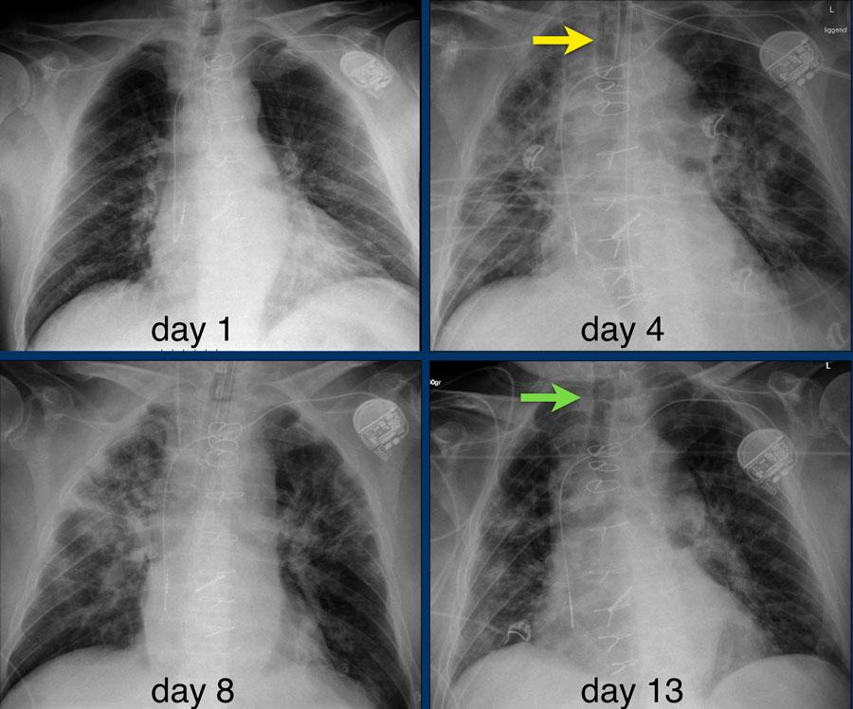

**Figure 1. day 1. normal findings day 4. bilateral consolidations intubated. day 8. bilateral consolidation day 13. extubation**

Machine Learning and deep learning applications in Medical Image is one of the most advanced research fields in the health sector as it also acts as an adjacent tool for the health workers. **[16]**. Deep learning is also an emerging field of research enabling to create advanced deep learning models to achieve precise and accurate results without the need for feature extraction **[17]** manually. Applications of deep learning include detection of pneumonia from Lung X-ray **[18]**, brain tumour segmentation **[19]**, lung cancer detection using 3D Convolution Networks **[20]**. Due to a limited number of radiologists, it is really a challenging task to test and examine a huge number of X-ray images due to the rapid increase of coronavirus infection. As for the scenario, AI-enabled and deep learning based automated solutions provide timely assistance to the radiologists, doctors and also helpful to obtain better results. **[21]**.It’s performance on the ImageNet image classification task was beyond human level performance which had ten lakhs images in the training phase in 2015, obtained promising results in the cancer detection of lungs in 2019 **[22] [23]**.

Recently, many deep neural networks have been proposed for the detection of early stages of COVID-19. Ceren Kaya et al. [24] obtained an accuracy of 98% for analyzing the COVID-19 from lungs X-Ray images using the ResNet-50 model. Wang et al **[25]** proposed an architecture of CNN named Covid-Netfor the early detection of COVID19, obtaining 92.4% accuracy in classifying COVID-19 classes, normal and non-COVID pneumonia. Sethy and Behra **[26]** obtained features and classified from different CNN along with Support Vector Machine(SVM) classifier for the best performance. Tulin Ozturk et al **[27]** proposed DarkCovidNet obtaining 98.08% in the binary classification task whereas 87.02% for the multiclass classification task.

This study aims to build and develop a fine tuned CNN architecture coupled with Transfer Learning which will assist in the early detection of Covid-19 pandemic and to develop deep learning lungs X-Ray images. The overall architecture requires raw radiological images of chest X-Ray and it provides a probability of Covid19 positive of the X-Ray image. We have trained our model with 141 COVID19 positive chest X-Ray Images, obtained briskly. We have used VGG16 as our base model with fine-tuning and transfer Learning.

**2 Methodology**

**2.1 Dataset Collection and findings:** In our thesis, Chest X-ray image samples are collected available in the GitHub public repository which was developed by Cohen JP **[28]**. The database is regularly updated by a group of researchers. Currently, there are a total of 141 samples of COVID19 positive. The dataset contains 57% of the male, 32% female and 12% other. In the dataset, metadata is given and the age distribution is provided. The normal X-ray images of Lung are collected from the public dataset repository of Kaggle**[29]**. There are a total of 1341 images in the X-ray dataset which are all resized into 224x224 pixels.

In **Figure 2** normal patient X-ray images are provided and in **Figure3** Covid19 positive X-Ray samples are provided.

**Figure 2. X-ray samples of normal patients**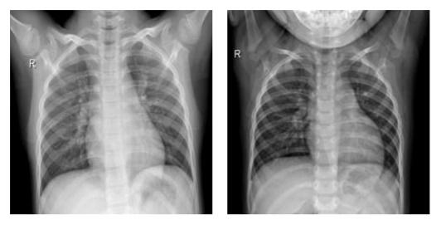

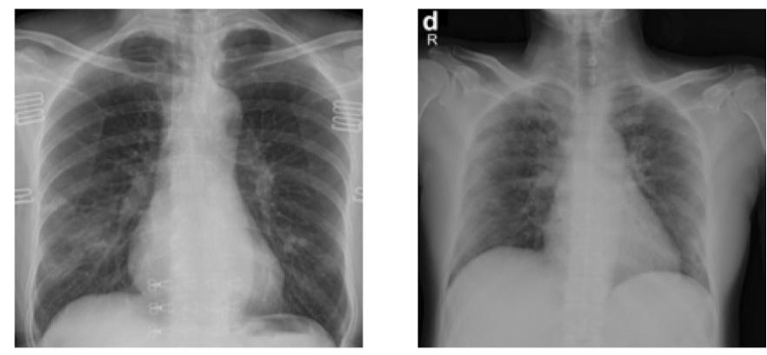

**Figure 3. X-ray samples of Covid19 Positive Images**

**2.2 VGG16 Architecture**

VGG16 is one of the best dense convolutional network models proposed by K. Simonyan and A. Zisserman mentioned in the paper titled “Very Deep Convolutional Networks for Large Scale Image recognition”.**[30] .** It is one of the most accurate models obtaining 92.7% accuracy in ImageNet Large Scale Visual Recognition challenge(ILSVRC) consisting of more than 14 million images belonging to 1000 classes. VGG16 is an improved version of AlexNet **[31]** by replacing the kernel filters of 3x3. It has 13 Convolution layers with 3 Dense layers . VGG16 is one of the dense networks consisting of 138 million parameters. The model takes an input image(RGB) of fixed size of 224x224 pixels. It uses 1x1 convolution filters for linear transformation of the input filters. Spatial pooling is performed by 5 max-pooling layers with window size of 2x2 and a stride amount of 2.

VGG16 consists of three Fully-Connected Convolution layers which have varying depths depending upon the architecture.First two consist of 4096 channels each and the third contains 1000 channels. Soft-max activation function is used in the final layer.

The mathematical formulation of 2D convolution is given in equation(1).



y[i,j] = \sum_{m=-\infty }^{\infty } \sum_{n=-\infty}^{\infty} h[m,n]\cdot x[i-m,j-n] -(1)

Where, x represents the input image matrix which is to be convoluted with the (3x3) kernel matrix h to result in a new feature map. Here y represents the output image and the indices i and j are related with the image matrices while m,n deal with the kernel. The indices m and n range from -1 to 1. We have used a stride matrix by (1,1).

The detailed layers and block architecture of the VGG16 model is shown in **Figure 4.**

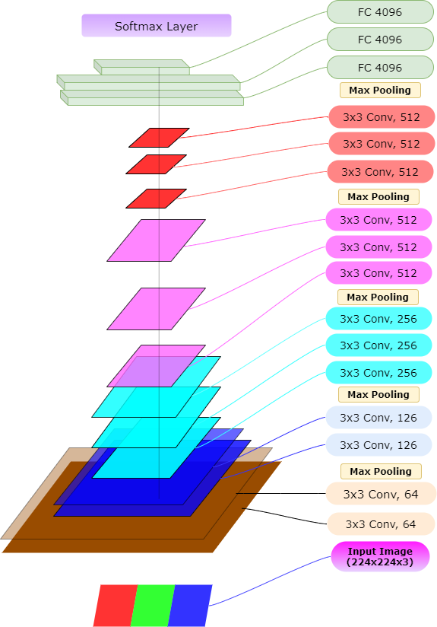

**Figure 4. VGG16 Architecture**

**2.3 Proposed Architecture of VGG16 with Transfer Learning**

Deep learning is one of the subfields of machine learning and the growth of deep learning has revolutionized in the domain of Artificial Intelligence(AI). Deep Learning Models have been used in extracting features from images to draw meaningful insights. The CNN Architecture has been named after the mathematical Convolution operation. The convolution layers are used to extract meaningful features using the input filters to create the feature map. Stacking these convolution layers a typical CNN model is formed which can be used in Image Classification, segmentation in medical data.

Pre-trained deep CNN models are available so developing a deep network model from root, a most robust approach is to use a proven pre-trained model. In the study of medical imaging, datasets availability is one of the most crucial problems which a data scientist often faces. Normally, to train a CNN model and to extract enough information from the data, a dense model requires a huge amount of data. In this case, transfer learning **[32]** and fine-tuning of the pre-trained model comes into play because it allows training of deep CNN models with a limited number of data resources. Transfer Learning is the methodology to reuse and tune a pre-trained model. Nevertheless, it is one of the growing research interests in the field of Deep Learning.**[33]**

So, In our study, we will be using a deep CNN based on VGG-16 for the detection of COVID-19 using two classes belonging to Normal patients and COVID-19 positive patients. In addition to this, we have implemented the transfer learning technique that has been utilized by using ImageNet data for overcoming insufficiency of data. The schematic representation of the VGG-16 CNN model has been depicted in Figure 4. We have frozen the top layers of the VGG-16 model fine-tuning the fully connected layers using transfer learning. We have used Average Pooling.The proposed architecture and fine tuned final block is provided in [**Figure**](https://www.ncbi.nlm.nih.gov/pmc/articles/PMC7187882/figure/fig4/) **5**.

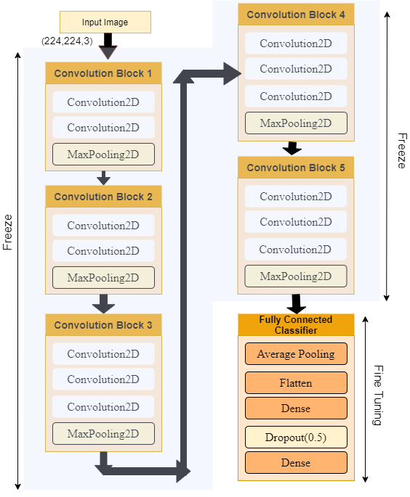

**Figure5. Fine Tuned VGG16 architecture**

For the pooling Layer MaxPooling method has been used. Max Pooling is used to reduce the input shape dimension and allow assumptions to be made about features. All the Convolution , Max-pooling layers and a number of trainable parameters of the proposed VGG16 is shown in **Table 1**. After freezing top layers for the training phase it consists of 14 million parameters. We have chosen a batch size of 8 and learning rate as 1e-3.

_____________________________________________________________________________

**Table1**

The Convolution blocks , dimensions and the number of trainable parameters of the model

|  |  |  |  |
| --- | --- | --- | --- |
| Layer No | Layer Type | Output Dimension | Trainable Parameters |
| 1 | Convolution2D | [224,224,64] | 1792 |
| 2 | Convolution2D | [224,224,64] | 36928 |
| 3 | Convolution2D | [112,112,128] | 73856 |
| 4 | Convolution2D | [112,112,128] | 147584 |
| 5 | Convolution2D | [56,56,256] | 295168 |
| 6 | Convolution2D | [56,56,256] | 590080 |
| 7 | Convolution2D | [28,28,256] | 590080 |
| 8 | Convolution2D | [28,28,512] | 1180160 |
| 9 | Convolution2D | [28,28,512] | 2359808 |
| 10 | Convolution2D | [28,28,512] | 2359808 |
| 11 | Convolution2D | [14,14,512] | 2359808 |
| 12 | Convolution2D | [14,14,512] | 2359808 |
| 13 | Convolution2D | [14,14,512] | 2359808 |
| 14 | Flatten | [512] | 0 |
| 15 | Dense[64] | [64] | 32832 |
| 16 | Dense[2] | [2] | 130 |

**__________________________________________________________________**

**3 Experimental Setup and Results**

We have used Python 3.6.5 and Kaggle eCloud GPU (P100) for the training purpose of our VGG16 deep neural model. We have developed a binary classification model which can accurately classify X-Ray images of two classes ,Covid19 Positive and Normal. The overall performance is computed using a 5-fold cross-validation strategy. For each fold the total feature space is splitted and 80% data has been used for training purpose and 20% for the validation purpose. The cross validation strategy is shown in **Figure 6**. In each fold our model is trained for 100 epochs and a total of 500 epochs.

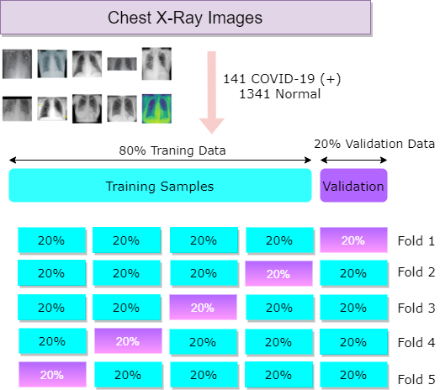

**Figure 6: Representation of the K-Fold Strategy**

The Training Accuracy , validation accuracy asd training validation losses for 5 folds of the VGG16 model is shown in **Figure 7**, **Figure 8**.

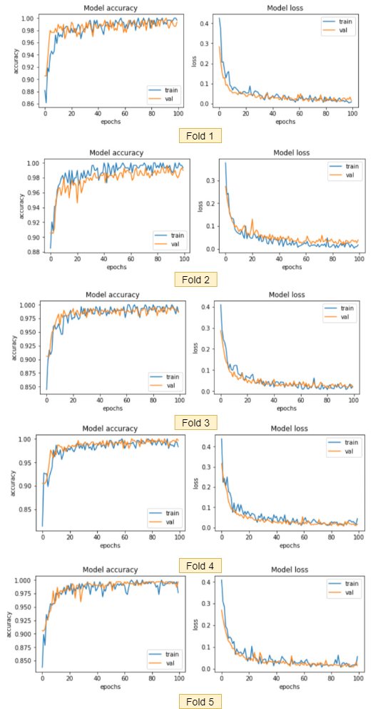

**Figure 7. Representative graph of Training and validation accuracy of 5 fold.**

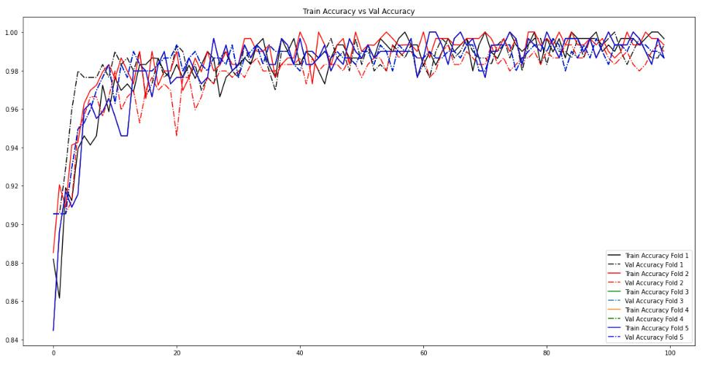

**Figure 8. Training and Validation accuracy curve over 100 epochs**

The details of the confusion matrices(CM) of each fold for two classes(COVID19 and normal) have been displayed in **Figure 9**.

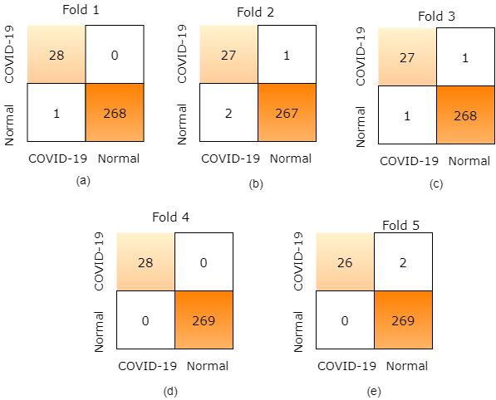

**Figure 9. (a) Fold 1 CM (b)Fold 2 CM (c) Fold 3 CM (d)Fold4 CM (e) Fold 5 CM**

The details of the performance metrics along with precision score, sensitivity score, specificity score, recall score and f1 score are shown in **Table 2**.

|  |  |  |  |  |  |  |
| --- | --- | --- | --- | --- | --- | --- |
| **5 Folds** | **Performance Metrics(%)** | | | | | |
|  | **Specificity** | **Sensitivity Score** | **Precision**  **Score** | **F1-score** | **Recall**  **Score** | **Accuracy** |
| **Fold1** | **99.62** | **100** | **100** | **98.24** | **96.55** | **99.66** |
| **Fold2** | **99.25** | **96.42** | **96.42** | **94.73** | **93.10** | **98.98** |
| **Fold3** | **99.62** | **96.42** | **96.42** | **96.42** | **96.42** | **99.33** |
| **Fold4** | **100** | **100** | **100** | **100** | **100** | **100** |
| **Fold5** | **100** | **92.85** | **92.85** | **96.29** | **100** | **99.32** |
| **Average** | **99.698** | **97.138** | **97.138** | **97.136** | **97.214** | **99.458** |

**Table2.** Specificity, Sensitivity, Precision, F1 score, Recall and Accuracy values of two classes COVID-19 nad Normal using VGG16 and Transfer Learning.

**Comparative Analysis with pretrained VGG16 and fine tuned VGG16 + Transfer Learning:** We have also trained our model using a pretrained VGG16 model to get a comparative analysis with our proposed model. The results are promising . The loss graph which is presented in **Figure 10** shows that sour fine tuning coupled with Transfer Learning model performed very well with respect to VGG16 alone.

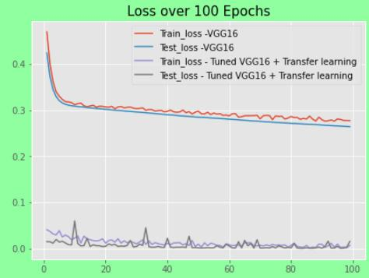

**Figure 10 : Comparative analysis graph of VGG16 and our Proposed fine tuned VGG16 model with transfer Learning.**

The ROC accuracy is coming to be 98%. The ROC Curve distribution is given in **Figure 11**.

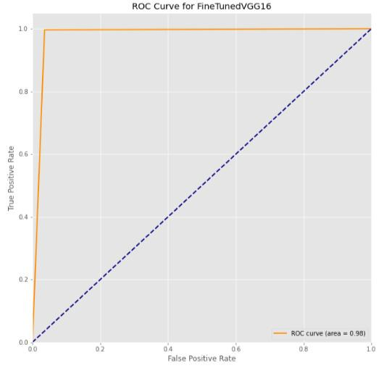

**Figure 11. ROC Accuracy of VGG16 + Transfer Learning**

From the above table the VGG16 model that we proposed achieved an average accuracy of 99.458 for the classification task. The average specificity, sensitivity, precision, F1-score and recall scores are found to be 99.698%,97.138%,97.138%,97.136% and 97.214% respectively.

**4 Discussion**

Radiological images of Chest X-ray images are being constantly updated by Dr. Cohen for the researchers to make an efficient and accurate model for the early stage detection of Covid19. Deep learning models specially Deep CNN are commonly used for extracting the features which are relevant from the samples of the X-ray images . The normal Chest X-ray images are available in public repositories , kaggle resources. Wang and Wong **[25]** proposed the architecture of COVID-Net, for the early stage detection of COVID19 . COVID-Net obtained an accuracy of 92.4% . They have used a sample size of sixteen thousand which are gathered from different public repositories. Ioannis et al. **[35]** applied transfer learning in the same COvid-Net model and he used a sample of 224 positive X-Ray images , 504 normal radiology images and 700 pneumonia. They obtained a 98.75% performance for the 2-class classification problem. Another study of Zheng et al**[34]** , showed that they have achieved 90.8% accuracy by using 313 positive samples of COVID19 and 229 Normal samples. Also Tulin Ozturk et al proposed their DarkCovidNet model obtaining 98.08% in binary classification task. They have used 125 COVID-19 positive Image samples and 500 No-findings for the purpose.**[27]**

In our proposed study we have used the base model as VGG16 and applied transfer learning and fine tuning. We have used 141 positive COVID-19 samples and 1341 Normal X-Ray Images from Kaggle. After 5 fold of cross validation we have obtained an average accuracy of 99.458% for binary classes which is more superior with comparison to other studies in this literature. **[Table 3][27]**

|  |  |  |  |  |
| --- | --- | --- | --- | --- |
| Related Studies | Training Samples type | Training Data Size | Model Architecture | Accuracy(%) |
| Wang et al.**[35]** | X-Ray samples(Chest) | 195 Positive  258Normal | M-Inception | 82.9 |
| Ying et al. **[36]** | CT images(Chest) | 777 Positive  708 Normal | DRE- Net | 86.0 |
| Xu et al. **[37]** | CT images(Chest) | 219 Positive  224 Viral pneumonia  175 Normal | ResNet + Location Attention | 86.7 |
| Hemdan et al **[38]** | X-Ray samples(Chest) | 25 Positive  25 Normal | COVIDX-Net | 90.0 |
| Zheng et a**l[39]** | Chest CT images | 313 Positive  229 Normal | 3D Deep Network + UNet | 90.8 |
| Wang and Wong**[25]** | X-Ray samples(Chest) | 53 Positive  5526 Normal | COVID-Net | 92.4 |
| Ioannis et al.**[40]** | X-Ray samples(Chest) | 224 Positive  700 Pneumonia  504 Normal | VGG-19 | 93.48 |
| Sethy & Behra**[26]** | X-Ray samples(Chest) | 25 Positive  25 Normal | ResNet50 with SVM Classifier | 95.38 |
| Tulin Ozturk et al**[37]** | X-Ray samples(Chest) | 125 Positive  500 Normal | DarkCovidNet | 98.08 |
| **Proposed Model** | X-Ray samples(Chest) | 141 Positive  1341 Normal | VGG16 + Transfer Learning | 99.458 |

Our proposed model can provide advanced assistance to the medical healthworks and in the detection of coronavirus. It will also help to reduce the time complexity of testing and limitation of resources. X-ray images are easily available and it has crucial information about the patient. But the only limitation is small training samples. The model performance can be improved by more samples. In addition, we have implemented an effective screening process for separating the frontal Chest X-Ray images . The major factors of our approach are as follows, -

* The images are gone through aggressive image augmentation techniques to reduce overfitting.
* Normally the VGG16 model takes about 138 million parameters but by freezing the layers and transfer learning the parameter size is reduced to 14 million parameters which is more time efficient.
* It could act as an effective and precise assistance to the experts.
* The proposed model does not deal with extraction of features which also reduces its complexity.
* Transfer Learning and fine tuning the last Fully Connected Layer perporfs very well with respect to the VGG16 model alone.
* The results are impressive although the sample space is very low and also the consistency is maintained along each fold.

In the future studies, we will work more on feature extraction and segmentation which will provide more accurate analysis of COVID-19. The model can be deployed in the cloud and it would act as an automated software of COVID-19 diagnosis very fast.

**5 Conclusion**

Covid-19 pandemic is really a devastating curse for human mankind and the daily rise of the infections and death rates are shocking. In this situation application of Artificial Intelligence and Deep Learning plays a vital role to ease this situation. In this thesis , the model which is proposed is an end to end architecture which will not need any manual feature extraction methods. It can be implemented for binary class detection and is ready to be tested for larger datasets. In rural areas, where enough testing kits are not available and also for immediate assistance this automated detection will fill the shortage of expert radiologists immensely. The only limitation of the model is small sample space. We are aiming for cloud deployment of our model and working on finding more X-ray samples and also CT-images for comparison analysis of the proposed model.

**6 References**

[1] World Health Organization, and World Health Organization (WHO). "Pneumonia of unknown cause–China', Emergencies preparedness, response." Disease outbreak news (2020).

[2] Kong, Weifang, and Prachi P. Agarwal. "Chest imaging appearance of COVID-19 infection." Radiology: Cardiothoracic Imaging 2.1 (2020): e200028.

[3] https://www.who.int/health-topics/coronavirus 20.03.2020

[4] Huang, C., Wang, Y., Li, X., Ren, L., Zhao, J., Hu, Y., Zhang, L., Fan, G., Xu, J., Gu, X.,Cheng, Z., Yu, T., Xia, J., Wei, Y., Wu, W., Xie, X., Yin, W., Li, H., Liu, M., Xiao, Y., Gao, H., Guo, L., Xie, J., Wang, G., Jiang, R., Gao, Z., Jin Q., Wang, J., and Cao, B. Clinical featuresof patients infected with 2019 novel coronavirus in Wuhan, China. The Lancet, 395(10223):497-506, 2020.

[5] https://www.worldometers.info/coronavirus/

[6] International committee on taxonomy of viruses (ictv) website. https://talk. ictvonline.org/. Accessed 14 Feb 2020.

[7] Mahase, E. Coronavirus: covid-19 has killed more people than SARS and MERS combined,

despite lower case fatality rate. The BMJ, 368 : m641, doi: 10.1136/bmj.m641, 2020.

[8] https://www.who.int/health-topics

[9] Ai, T., Yang, Z., Hou, H., Zhan, C., Chen, C., Lv, W., Tao, X., Sun, Z., and Xia, L.

Correlation of Chest CT and RT-PCR Testing in Coronavirus Disease 2019 (COVID-19) in

China: A Report of 1014 Cases. Radiology, 200642: 1-23,

https://doi.org/10.1148/radiol.2020200642, 2020.

[10] Radiopedia Blog: https://radiopaedia.org/articles/covid-19-3

[11] The Hindu Magazine: https://www.thehindu.com/sci-tech/science/covid-19-what-are-the-different-types-of-tests/article31507970.ece

[12] L. Lan, D. Xu, G. Ye, C. Xia, S. Wang, Y. Li, H. XuPositive RT-PCR test results in patients recovered from COVID-19Jama, 323 (15) (2020), pp. 1502-1503

[13] Z.Y. Zu, M.D. Jiang, P.P. Xu, W. Chen, Q.Q. Ni, G.M. Lu, L.J. Zhang Coronavirus disease 2019 (COVID-19): a perspective from China Radiology (2020),10.1148/radiol.2020200490 In press

[14] Kong, Weifang, and Prachi P. Agarwal. "Chest imaging appearance of COVID-19 infection." Radiology: Cardiothoracic Imaging 2.1 (2020): e200028.

[15] https://radiologyassistant.nl/chest/covid-19-ct-findings-in-25-patients

[16] G. Litjens, T. Kooi, B.E. Bejnordi, A.A.A. Setio, F. Ciompi, M. Ghafoorian, ..., C.I. Sánchez A survey on deep learning in medical image analysis

[17] Chen, Yushi, et al. "Deep feature extraction and classification of hyperspectral images based on convolutional neural networks." IEEE Transactions on Geoscience and Remote Sensing 54.10 (2016): 6232-6251.

[18] Rajpurkar, Pranav, et al. "Chexnet: Radiologist-level pneumonia detection on chest x-rays with deep learning." arXiv preprint arXiv:1711.05225 (2017).

[19] Shahzadi, Iram, et al. "CNN-LSTM: Cascaded framework for brain Tumour classification." 2018 IEEE-EMBS Conference on Biomedical Engineering and Sciences (IECBES). IEEE, 2018.

[20] Huang, Xiaojie, Junjie Shan, and Vivek Vaidya. "Lung nodule detection in CT using 3D convolutional neural networks." 2017 IEEE 14th International Symposium on Biomedical Imaging (ISBI 2017). IEEE, 2017.

[21] Caobelli, Federico. "Artificial intelligence in medical imaging: Game over for radiologists?." European journal of radiology 126 (2020): 108940-108940.

[22] Kaiming He, Xiangyu Zhang, Shaoqing Ren, and Jian Sun. Delving deep into rectifiers: Surpassing human-level performance on imagenet classification. In Proceedings of the IEEE international conference on computer vision, pages 1026–1034, 2015.

[23] Diego Ardila, Atilla P Kiraly, Sujeeth Bharadwaj, Bokyung Choi, Joshua J Reicher, Lily Peng, Daniel Tse, Mozziyar Etemadi, Wenxing Ye, Greg Corrado, et al. End-to-end lung cancer screening with three-dimensional deep learning on low-dose chest computed tomography. Nature medicine, 25(6):954–961, 2019.

[24] Narin, Ali, Ceren Kaya, and Ziynet Pamuk. "Automatic detection of coronavirus disease (covid-19) using x-ray images and deep convolutional neural networks." arXiv preprint arXiv:2003.10849 (2020).

[25] Wang, Linda, and Alexander Wong. "COVID-Net: A tailored deep convolutional neural network design for detection of COVID-19 cases from chest radiography images." arXiv (2020): arXiv-2003.

[26] Sethy, Prabira Kumar, and Santi Kumari Behera. "Detection of coronavirus disease (covid-19) based on deep features." Preprints 2020030300 (2020): 2020.

[27]Ozturk, Tulin, et al. "Automated detection of COVID-19 cases using deep neural networks with X-ray images." Computers in Biology and Medicine (2020): 103792.

[28] Cohen, Joseph Paul, Paul Morrison, and Lan Dao. "COVID-19 image data collection." arXiv preprint arXiv:2003.11597 (2020).

[29] https://www.kaggle.com/paultimothymooney/chest-xray-pneumonia

[30] Simonyan, Karen, and Andrew Zisserman. "Very deep convolutional networks for large-scale image recognition." arXiv preprint arXiv:1409.1556 (2014).

[31] Iandola, Forrest N., et al. "SqueezeNet: AlexNet-level accuracy with 50x fewer parameters and< 0.5 MB model size." arXiv preprint arXiv:1602.07360 (2016).

[32] Hon, Marcia, and Naimul Mefraz Khan. "Towards Alzheimer's disease classification through transfer learning." 2017 IEEE International conference on bioinformatics and biomedicine (BIBM). IEEE, 2017.

[33] Al Mufti, Maha, et al. "Automatic target recognition in SAR images: Comparison between pre-trained CNNs in a tranfer learning based approach." 2018 International Conference on Artificial Intelligence and Big Data (ICAIBD). IEEE, 2018.

[34] Zheng, Chuansheng, et al. "Deep learning-based detection for COVID-19 from chest CT using weak label." medRxiv (2020).

[35] Wang, Shuai, et al. "A deep learning algorithm using CT images to screen for Corona Virus Disease (COVID-19)." MedRxiv (2020).

[36] Song, Ying, et al. "Deep learning enables accurate diagnosis of novel coronavirus (COVID-19) with CT images." medRxiv (2020).

[37] Xu, X., X. Jiang, and C. Ma. "Deep Learning System to Screen Coronavirus Disease 2019 Pneumonia. arXiv e-prints 2020."

[38] Hemdan, Ezz El-Din, Marwa A. Shouman, and Mohamed Esmail Karar. "Covidx-net: A framework of deep learning classifiers to diagnose covid-19 in x-ray images." arXiv preprint arXiv:2003.11055 (2020).

[39] Zheng, Chuansheng, et al. "Deep learning-based detection for COVID-19 from chest CT using weak label." medRxiv (2020).

[40] Apostolopoulos, Ioannis D., and Tzani A. Mpesiana. "Covid-19: automatic detection from x-ray images utilizing transfer learning with convolutional neural networks." Physical and Engineering Sciences in Medicine (2020): 1.